**University of Maryland Global Campus**

**Library Management System (LMS)**

**User’s Guide**

**CMSC 495 7380 6 May 2023**

**Version 1.4**

**Group 3: Brandon Durham, Benjamin Kus, Benjamin Ramos**

|  |  |  |  |  |  |  |  |  |  |  |  |  |  |  |  |  |  |  |  |  |  |  |  |  |  |  |  |  |  |  |  |  |  |  |  |  |
| --- | --- | --- | --- | --- | --- | --- | --- | --- | --- | --- | --- | --- | --- | --- | --- | --- | --- | --- | --- | --- | --- | --- | --- | --- | --- | --- | --- | --- | --- | --- | --- | --- | --- | --- | --- | --- |
| **Revision History**   |  |  |  |  | | --- | --- | --- | --- | | **REVISION** | **DATE** | **DESCRIPTION** | **Author** | | 1.0 | 4/30/2023 | Initial | Ben Ramos | | 1.1 | 5/1/2023 | Modification to Requirements | Ben Kus | | 1.2 | 5/4/2023 | Modifications to Add Books,  Remove Books, and Issue Books Addition of display windows | Brandon Durham Ben Kus | | 1.3 | 5/5 | Modification to Module Installation | Ben Ramos | | 1.4 | 5/6 | Final Revisions | Ben Ramos  Brandon Durham Ben Kus | |  |  |  |  | |  |  |  |  | |  |  |  |  |                                                                       2 |

**Table of Contents**

Contents

1. **Introduction ...............................................................................................................................4**
2. **Requirements .............................................................................................................................4**

System Requirements ............................................................................................................................... 4

1. **Installation .................................................................................................................................4**

Downloading Source Code ........................................................................................................................ 5

Installing Modules ..................................................................................................................................... 5

1. **Operations ............................................................................................................................... 13**

LMS Start-Up ........................................................................................................................................... 13

Log In ....................................................................................................................................................... 13

Issuing a Book ......................................................................................................................................... 14

Adding a Book ......................................................................................................................................... 16

Removing a Book .................................................................................................................................... 18

Searching for a Book ............................................................................................................................... 19

Log Out .................................................................................................................................................... 22

|  |  |
| --- | --- |
| **1.**  **2.**  **3.** | **Introduction**  A library management system is a project which aims in developing an application to maintain the book catalog of a library. The purpose of this is to provide administrators with the ability to conduct daily maintenance to its book catalog. It will provide an easy and administrator-friendly way to track books, add and remove users, as well as track overdue books and numerous other functions.  ***Initial setup of MySQL Community is required for this Library Management System Application.***    **Requirements**  *System Requirements*  The following are the minimum required system and software to support the Library Management System:   * Processors:   Intel Core 2 Duo 1.8 GHz   * Memory:   2 GB of RAM   * Disk space:   150 GB   * Operating Systems: Windows 10 * Applications:   1. Eclipse IDE   2. Java   3. Java Swing   4. MySQL Community Server   5. MySQL JDBC Connector     The Library Management System is maintained on the Social Software Development Site GitHub and can be retrieved at [Library Management System](https://github.com/kusbenjamin/LibraryManagementSystem/tree/main/LMS%20Java%20Files) To install the LMS for initial use, please follow the below Installation guidelines.      **Installation**  To install the Library Management System, Eclipse IDE along with JDK X.X or higher. Please refer to [Eclipse Install Downloads](https://www.eclipse.org/downloads/) and [Overview of JDK Installation](https://docs.oracle.com/en/java/javase/20/install/overview-jdk-installation.html) prior to installing the LMS.    4 |

# Downloading Source Code

1. Download the Source Code (src folder) from https://github.com/kusbenjamin/LibraryManagementSystem
2. The contents should be the following: (LMS Java Files)
   1. Main.java
   2. LoginLogoutUI.java
   3. AddBook.java iv. RemoveBook.java
   4. SystemUI.java
   5. SearchBook.java
   6. IssueBook.java
   7. LMSSQL.sql (Found in LMS SQL File Folder) *Installing Modules*

Java provides default packages such as Abstract Window Toolkit (AWT) & Swing packages to create user interfaces (UI) for desktop applications. Also, we need to add this library: MysqlJDBC-connector.

1. Download [MySQL-connector](https://jar-download.com/artifacts/mysql/mysql-connector-java)

a. To Import:

i. Right-click on LMS and select Build Path >> Configure Build Path.

ii.

Select “Libraries”

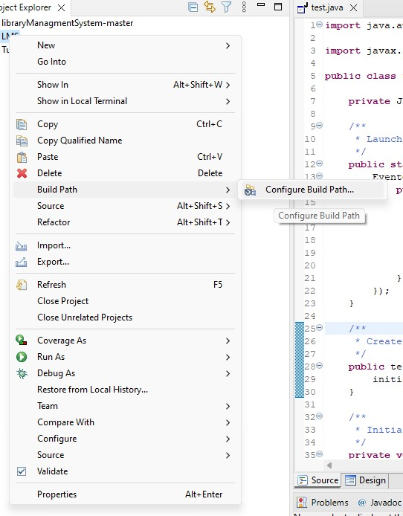

* + - 1. Select “Add External Libraries” on the left-hand side

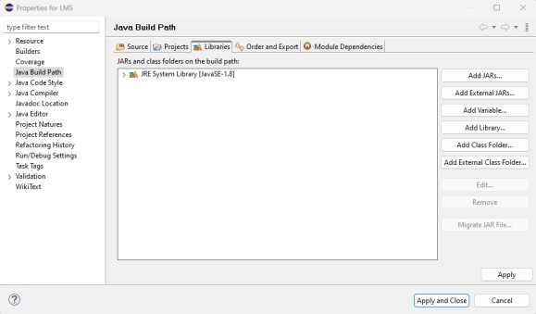

* + - 1. Navigate to the location on your system where the MySQL Connector file is located and select that file

v.

Select “Apply and Close”

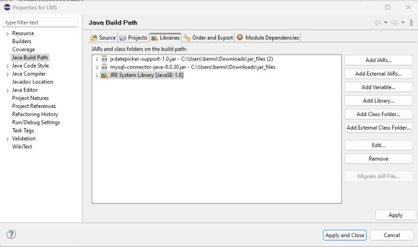

# Installing MySQL Community

1. [Download the MySQL Community Installer](https://dev.mysql.com/downloads/)

2.

Launch the

MySQL Community

Installer

,

Select the 1

st

option

(

De

veloper

Default

)

then click

“

next

”

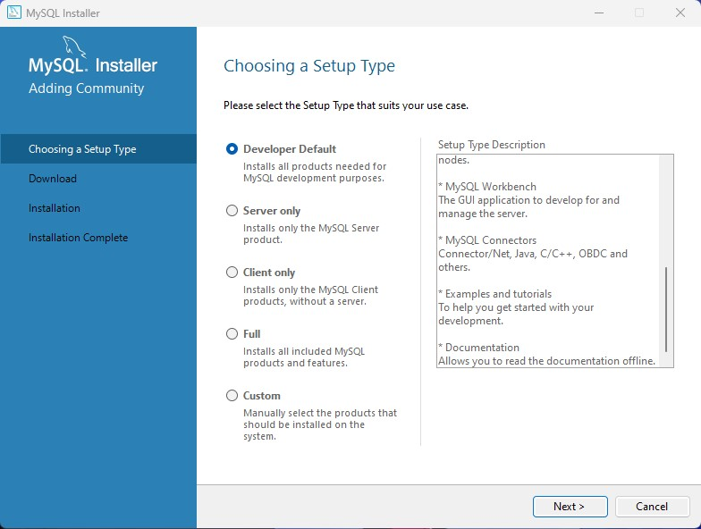

3. Select Execute

4.

Wait for Install

ation to finish

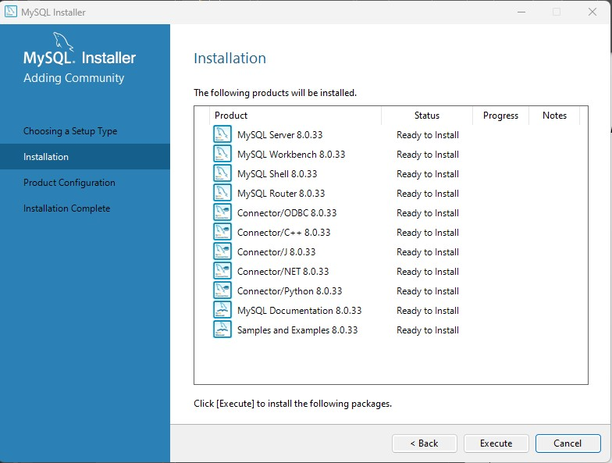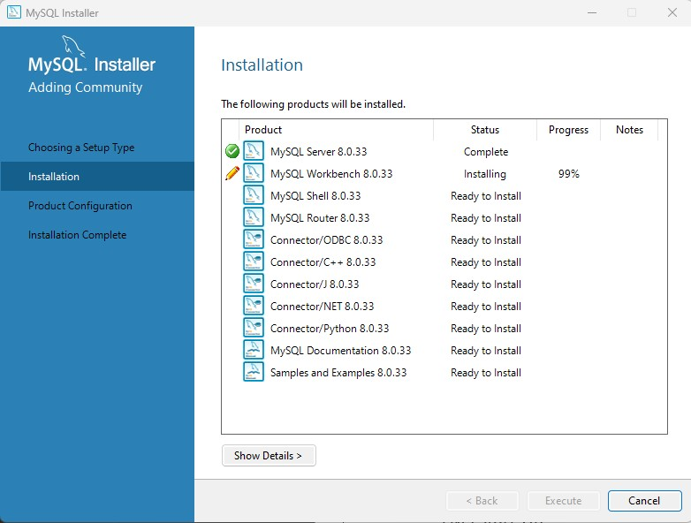

5. Click next

6.

Click Next

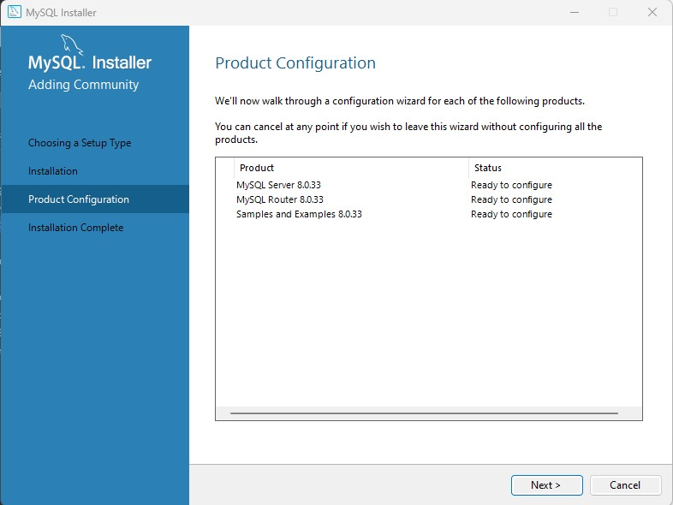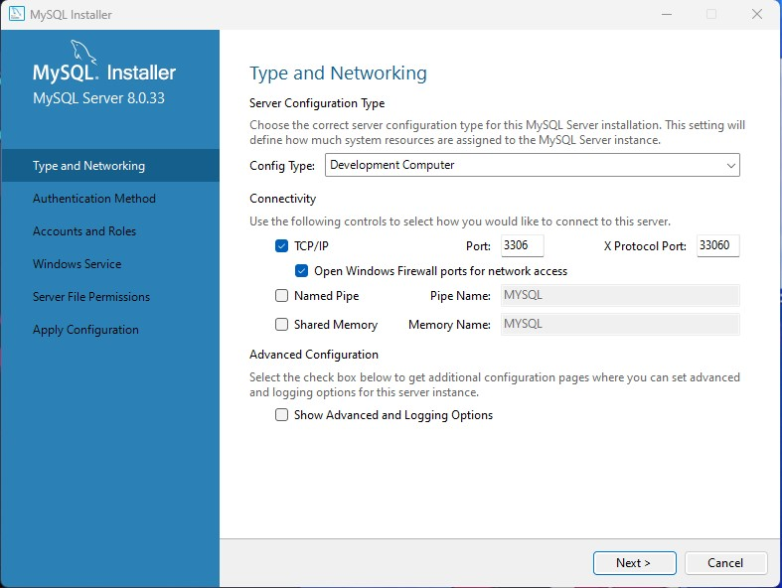

1. Click Next

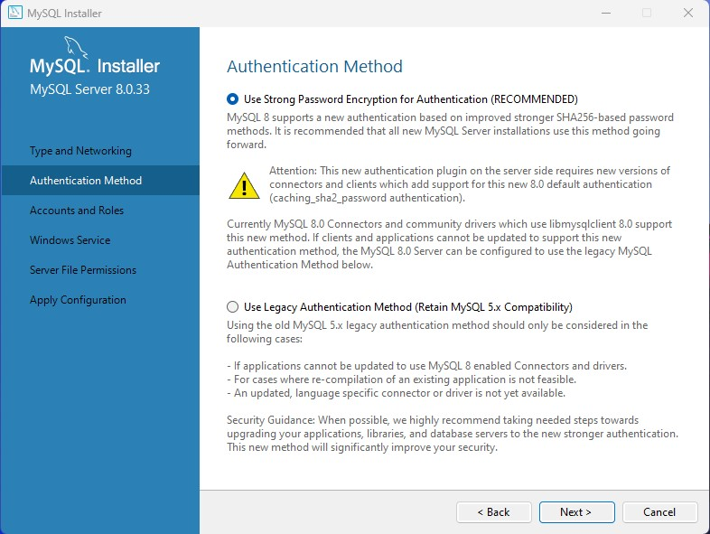

1. Enter this password for the Root (Admin) Account then click next: **CMSC4957380**

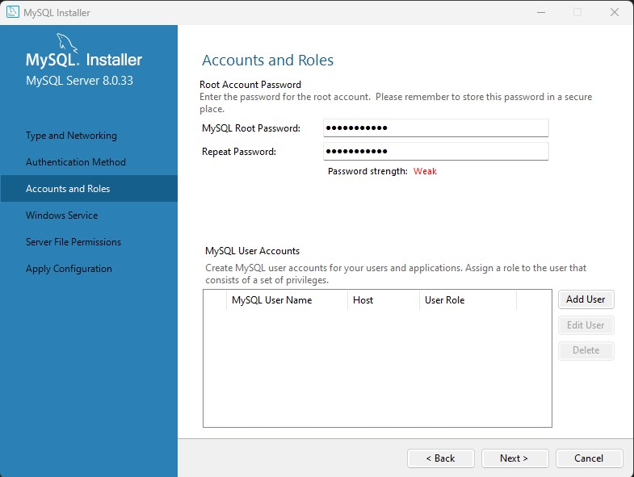

1. Click Next

10.

Click Next

11.

Click Execute and wait

for installer to finish

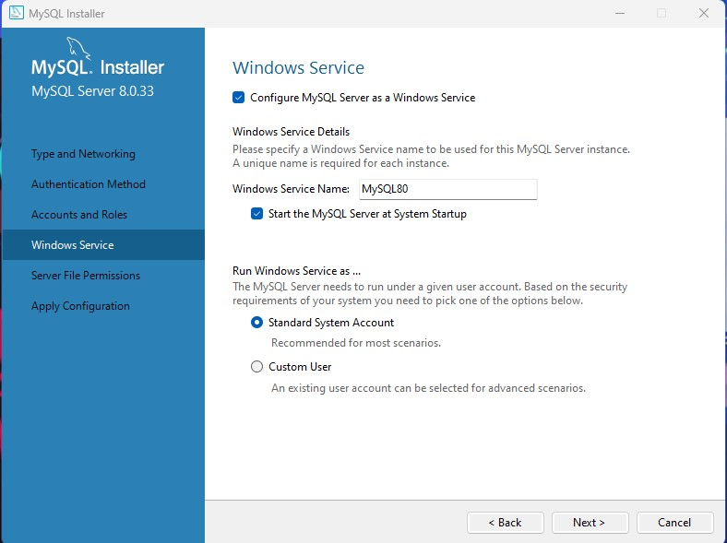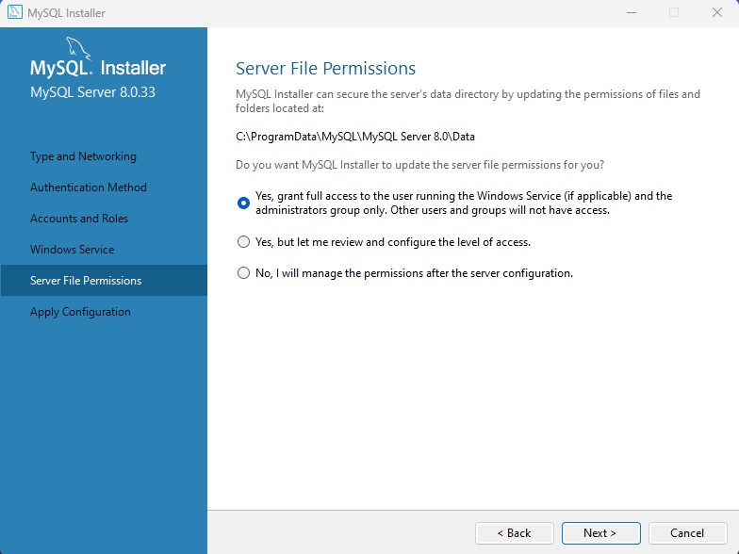

12.

Click

Finish

13.

C

l

ick

Cancel for Router and Samples and Examples to get

here:

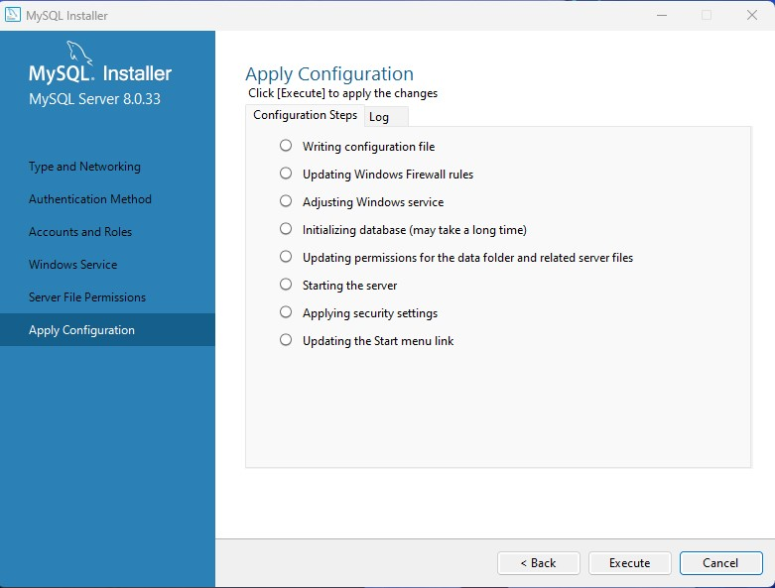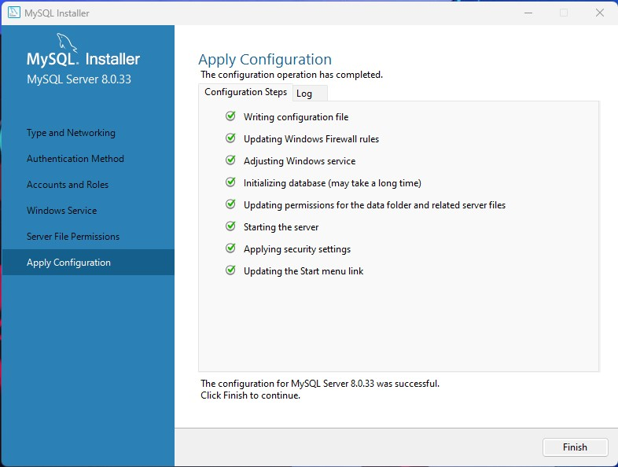

14.

Launc

h MySQL Workbe

nch

click on Local Instance

15.

Enter the password

that was set

in step 8

16.

Run th

e

provided SQL Script

(

GitH

u

b)

w

ithin Query 1

W

indow

by clicking the lightning

bolt

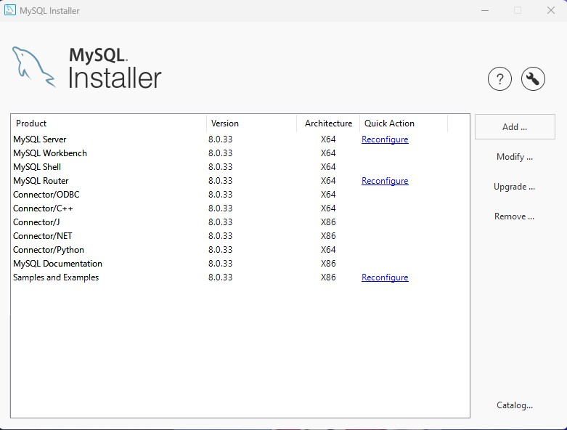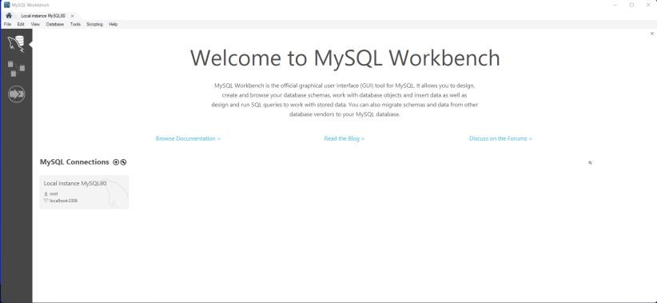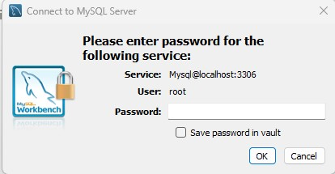

**4.**

**Operations**

*LMS Start*

*-*

*Up*

•

From the src directory type:

Main.java

*Log In*

•

The LMS application has started when you see the following

screen.

•

Enter the Username

“

admin1

”

in the designated “User

n

ame” block

.

•

Enter the Password

“

GummyBear973

”

in the designated “Password”

block.

•

When

User

n

ame and Password are entered correct

ly

the

System menu

screen will

be displayed

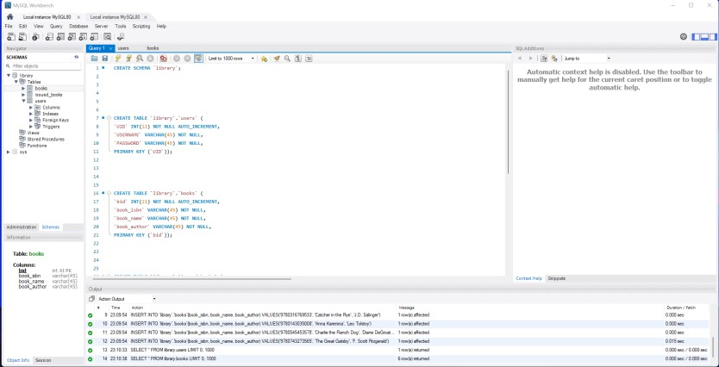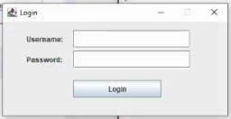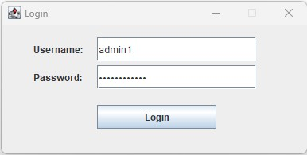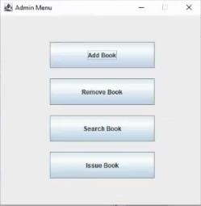

• A message will be displayed if an incorrect Username or Password is entered incorrectly.

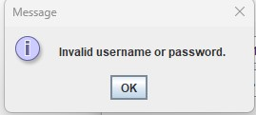

# Issuing a Book

* From the Librarian’s Screen, click on Issue Book



* Enter the ISBN in the designated “ISBN” block, followed by the Title and

Author

* Enter the Borrower’s First Name and Last in the designated block.
* Enter the Borrower’s Home Address in the “Address” block.
* Enter the Borrower’s Email Address in the “Email” block.
* Click “Issue” to Issue the Book. The book will then be entered into the database and a message will be displayed that the book was issued will be displayed.

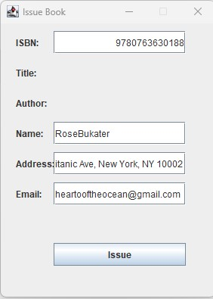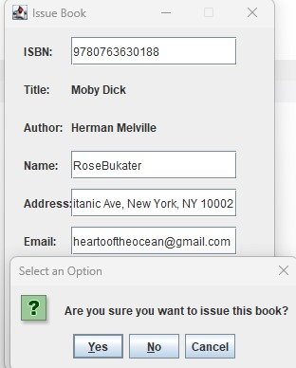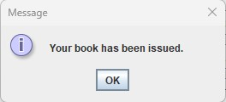

# Adding a Book

* From the Librarian’s Screen, click on “Add Book”.

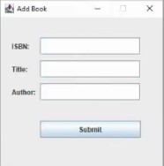

* Enter the ISBN in the designated “ISBN” block. The ISBN can only be numbers. Symbols (ex. !@#^) or letters are not valid inputs
* Enter the Book Title in the designated “Title” block.
* Enter the Author’s Name in the designated “Author” block.

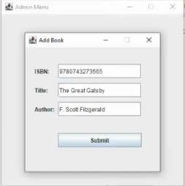

* Click “Submit” to add the book. The book will then be entered into the database and a message will be displayed that the book was added.

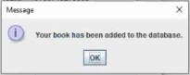

* To cancel adding a book, click “X” in the upper right corner of the Add Book Window.



* If the book was not added to the library a message will be displayed “Failure to Add Book”.

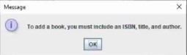

# Removing a Book

•

From the Librarian’s Screen, click on “Remove

Book.

”

•

Enter the

ISBN

in the designated “

ISBN

” block

.

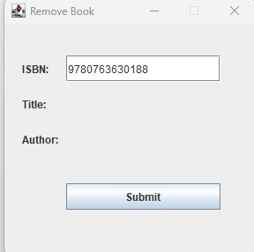

* Click “Submit” to remove the book. The book will then be removed from the database and a message will be displayed that the book was removed will be displayed.

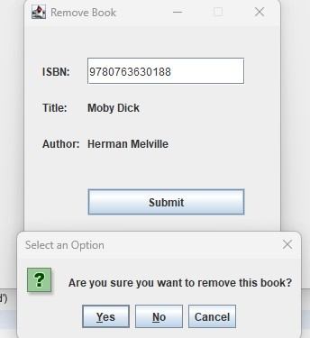

* If the book cannot be found, an error message will be displayed indicating the book could not be found and removed.

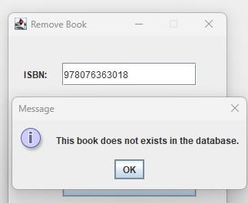

# Searching for a Book

* From the Librarian’s Screen, click on “Search Book.”

•

T

o Search for a book, e

nter the

ISBN

in the designated “

ISBN

” block

.

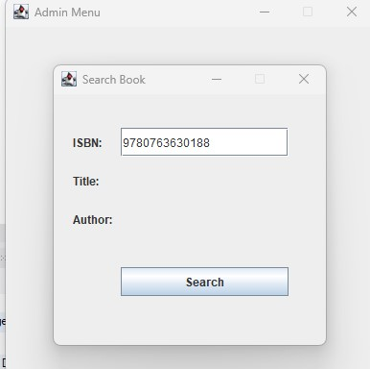

* Click “Submit” to search for the book. The administrator to then be given a choice to remove or issue the book. The administrator will also have the option to close the window and return the Librarian’s menu.

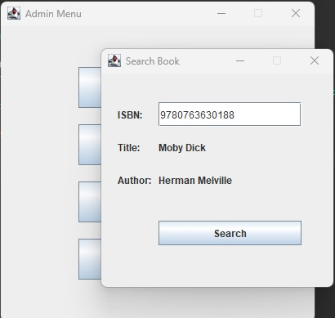

* If the book cannot be found, an error message will be displayed indicating the book could not be found.

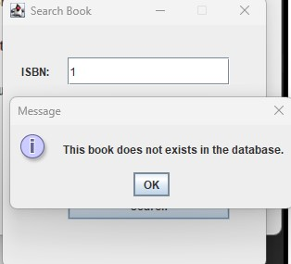

# Log Out

•

From t

he admin Menu

click the

X

.

•

A

message will appear stating

you

’

ve been logged out.

